PHASE 6 – TESTING AND VALIDATION

6.1 Testing the Project
The developed ServiceNow automation flow was tested to verify whether the configured trigger, conditions, and actions were working correctly. A test record was selected and the flow was executed using the Test option in Flow Designer.
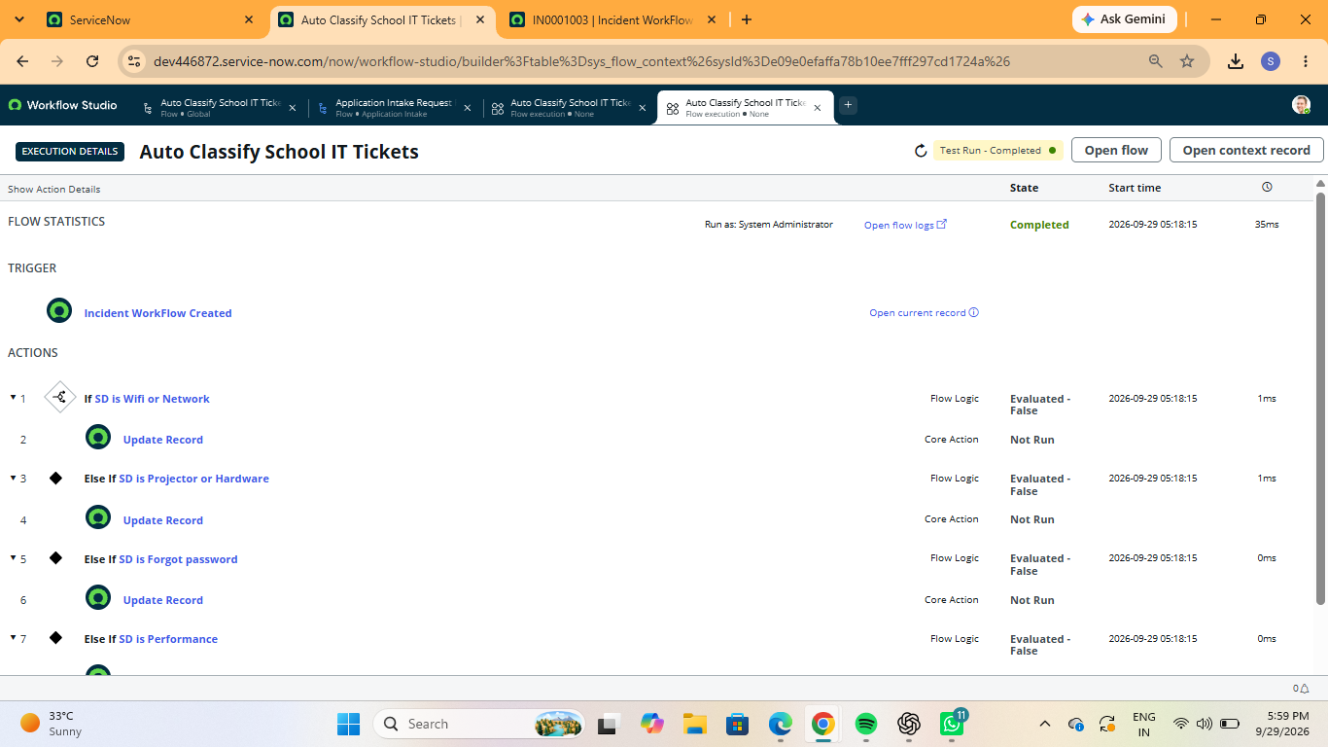
Figure 6.1: Testing the ServiceNow automation flow

6.2 Testing Different Ticket Conditions
Different ticket conditions were tested to verify whether the flow correctly identified the ticket category and executed the appropriate condition. The flow was tested with conditions such as WiFi or Network, Projector or Hardware, Forgot Password, and Performance.
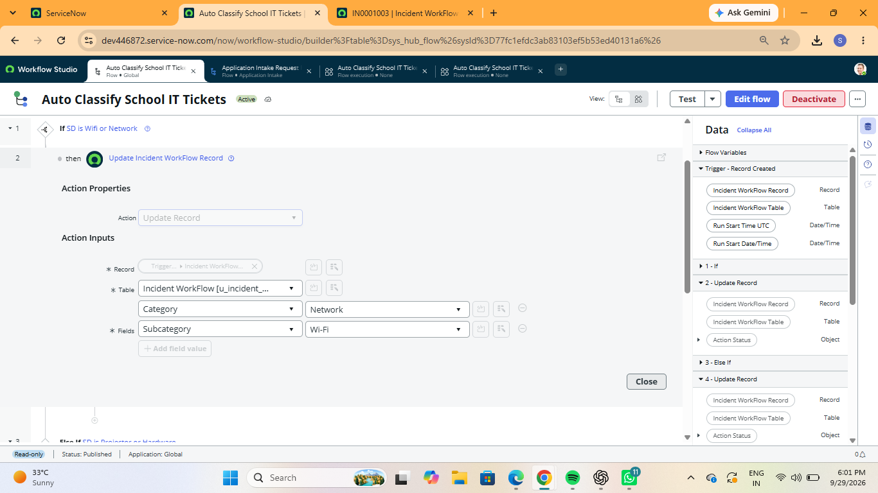
Figure 6.2: Testing different ticket conditions

6.3 Verifying Automated Actions
The configured actions were verified to ensure that the required operations were performed automatically based on the selected ticket condition. The Update Record and Send Email actions were checked during flow execution.
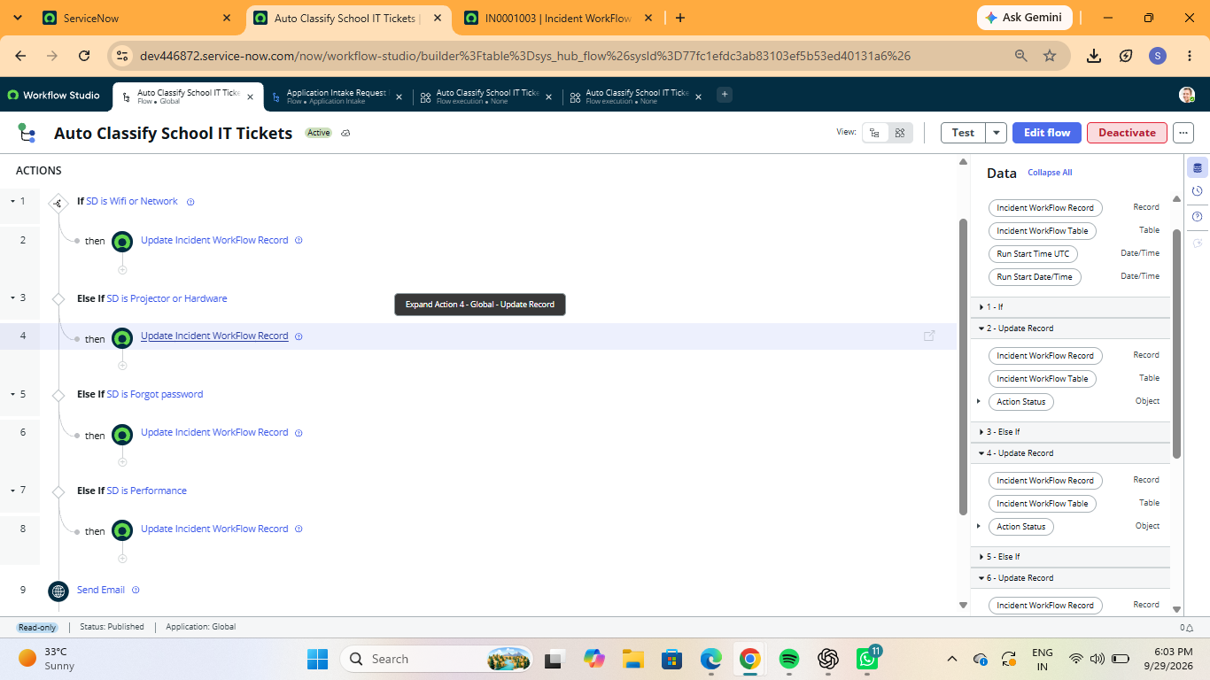
Figure 6.3: Verifying the automated actions

6.4 Validation of Output
After the flow execution, the ticket record was checked to verify whether the expected changes were applied automatically. The updated ticket information was examined to confirm the output of the automation process.

6.5 Testing Result
The testing process was completed successfully. The flow execution details were reviewed to verify the status of the configured conditions and actions. The test results confirmed that the automation flow was executed according to the configured workflow logic.
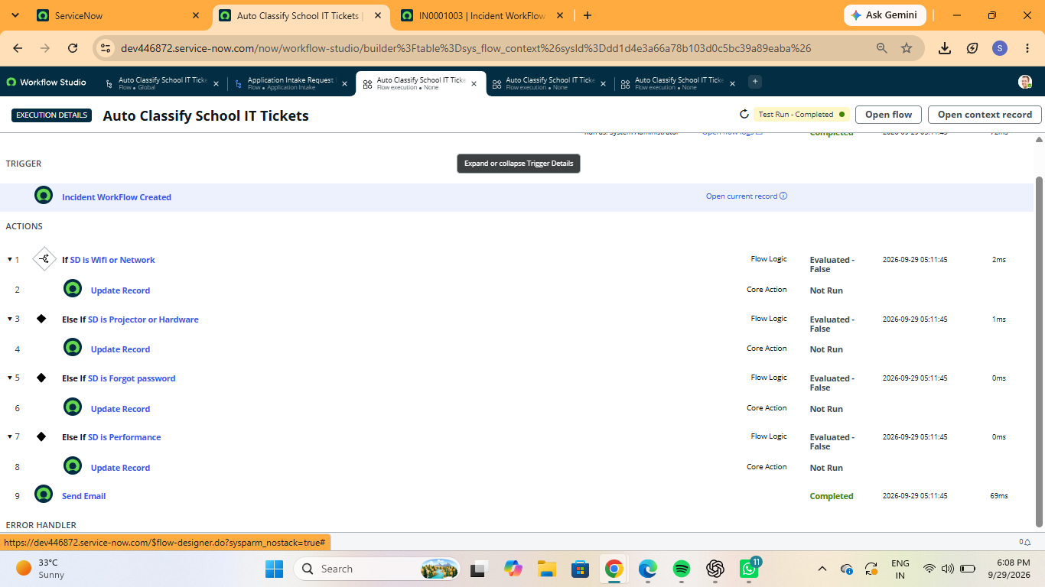
Figure 6.5: Overall testing result

